Task on VPC
- Create VPC with 2 private and 2 public subnets.
- Log in to the AWS Management Console.

AWS Cloud
│
└── Your VPC
│
├── Public Subnet
├── Public Subnet
├── Private Subnet
└── Private Subnet

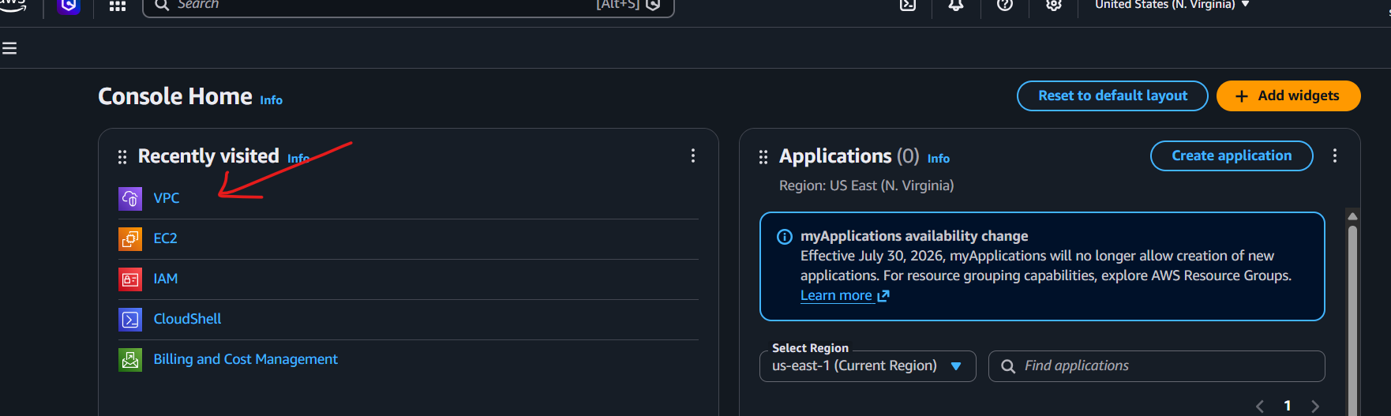
- Go to VPC → Your VPCs → Create VPC.
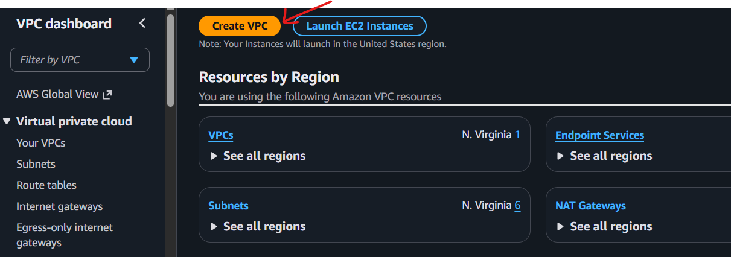
- Select VPC only.
- Enter:
- Name: My-VPC
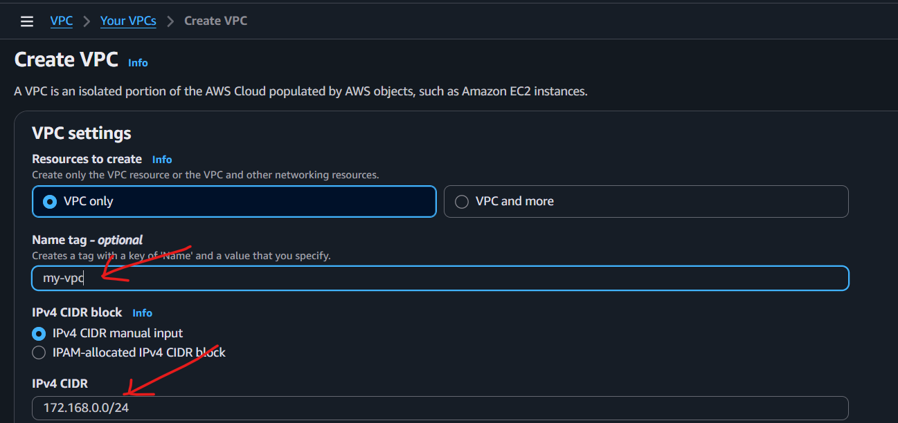
- IPv4 CIDR: 172.168.0.0.0/24
- Got to my vpc
Select my-vpc
Click on VPC ID
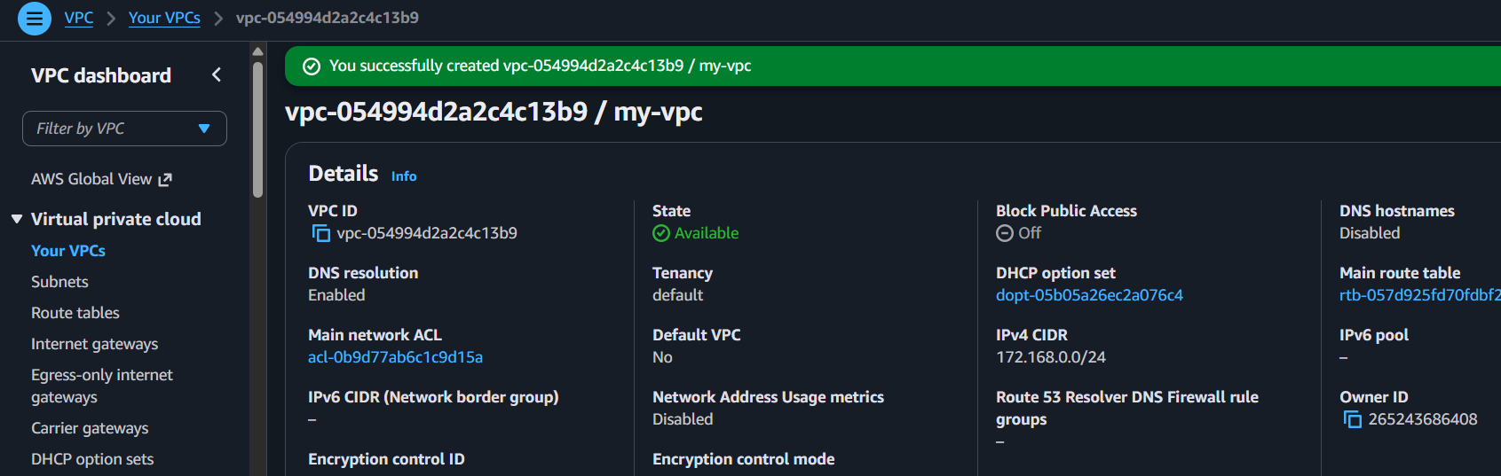

Create private subnet 1

- Virtual private cloud --subnet
- Click on subnet
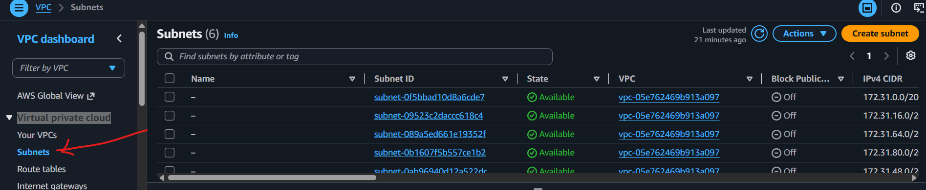

- Click on create subnet
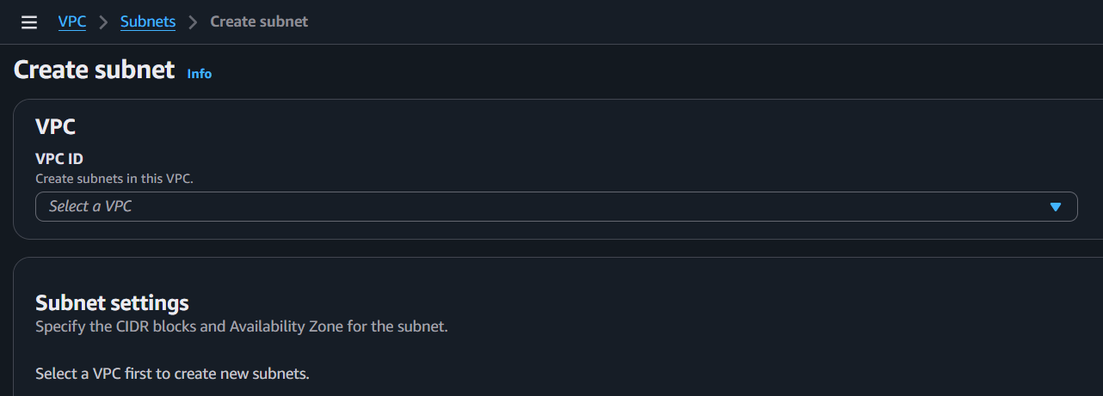
- VPC ID : select my-vpc
Subnet name: pri-subnet-01
IPV4:172.168.0.16/28

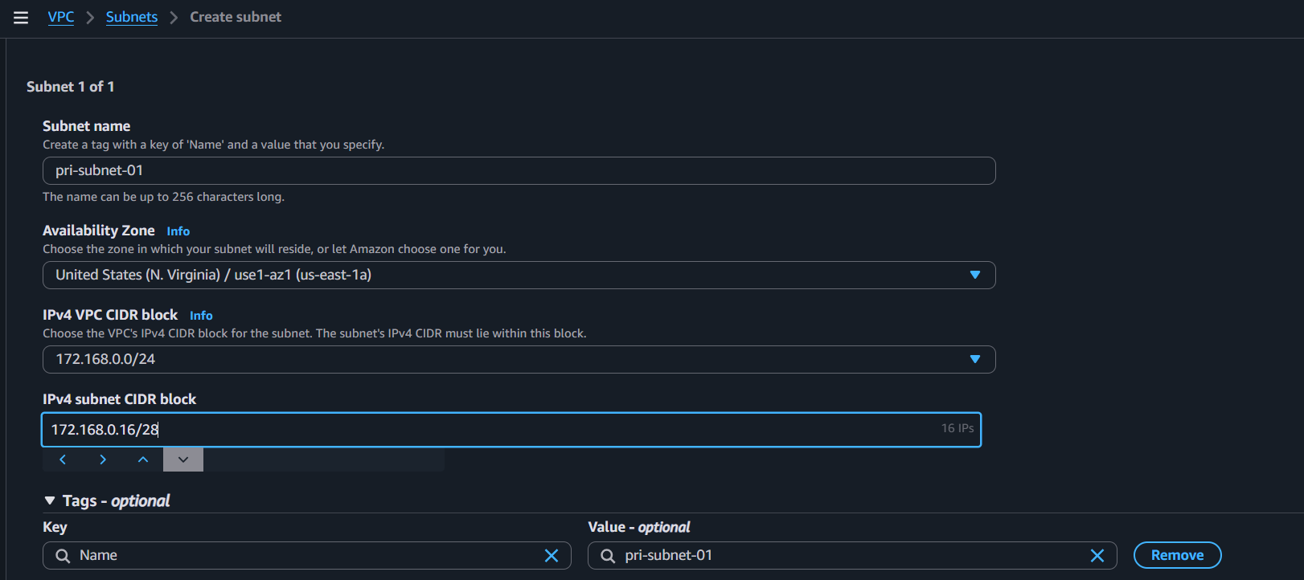
Click on create
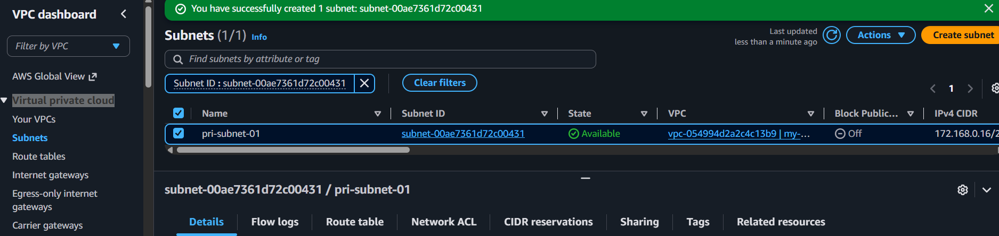

- Create private subnet 2
IPV4:172.168.0.32/28
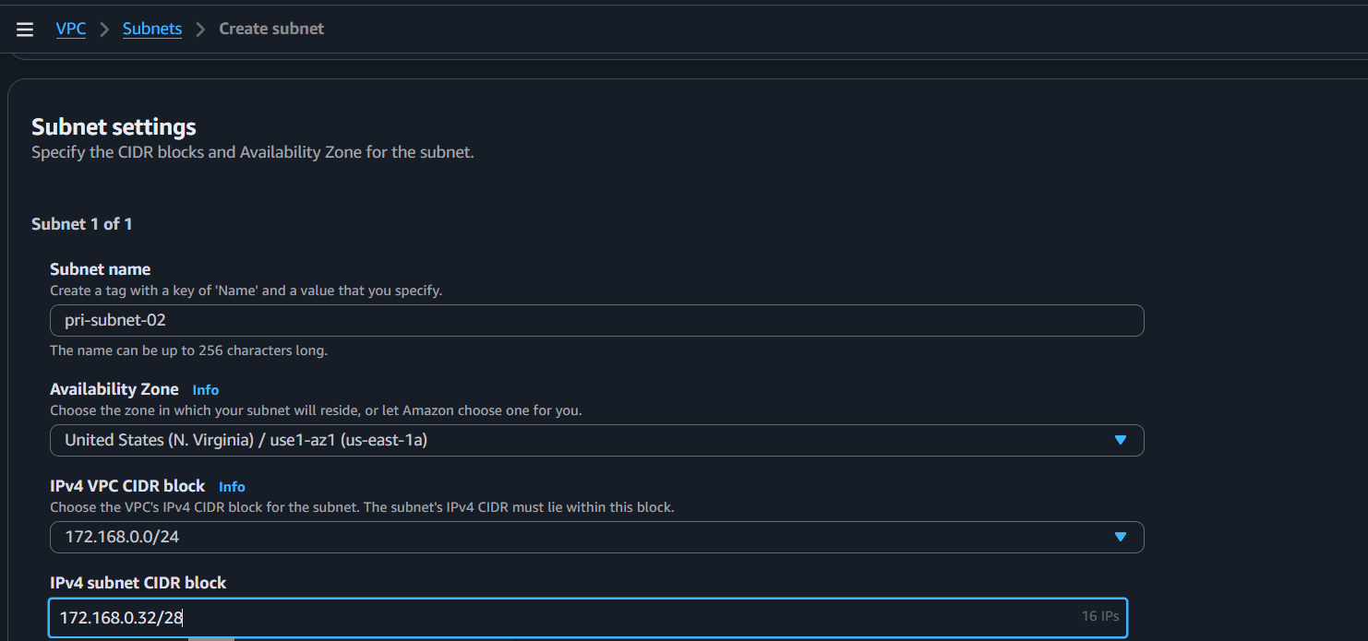

Subnet created
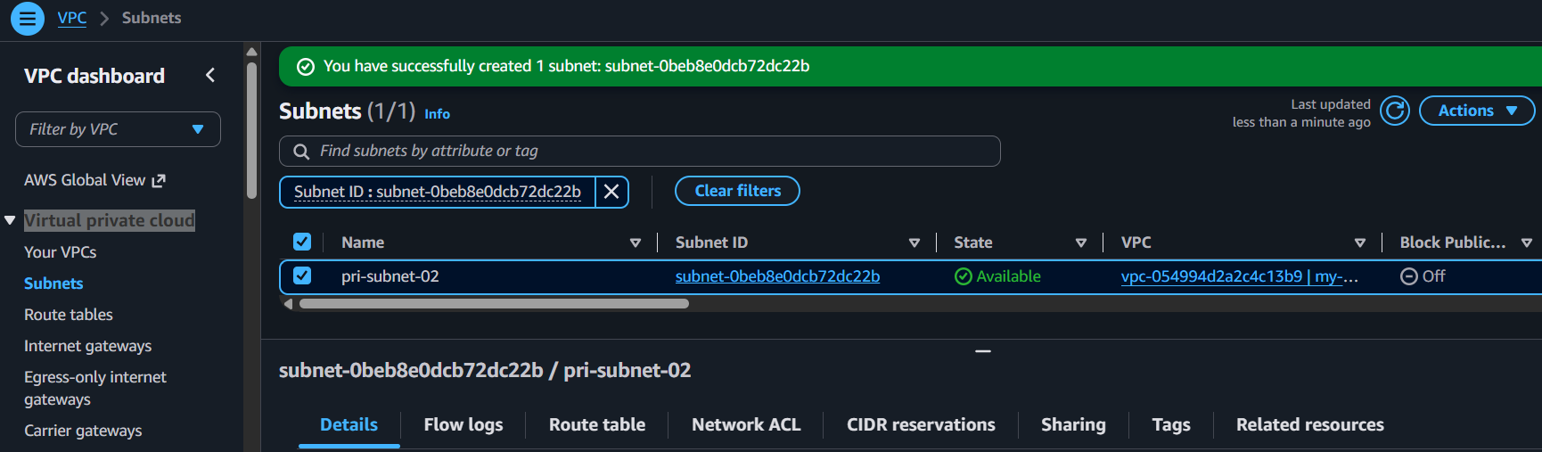

- Public Subnets: 2
Click on create subnet
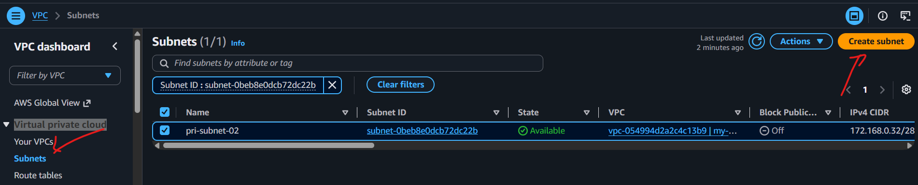
- Select VPC ID : my-vpc
- Name: pub-subnet-01
- IPv4 subnet CIDR block : 172.168.0.0/28
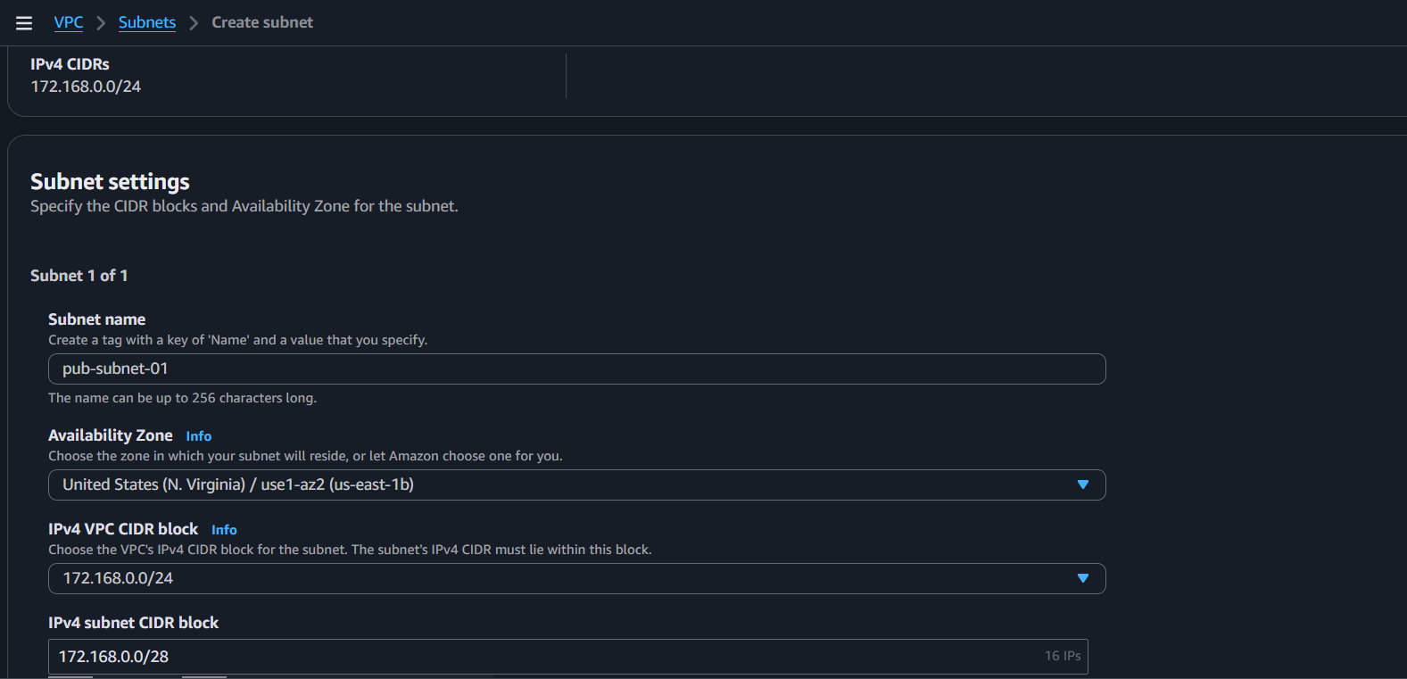

- Select VPC ID : my-vpc
- Name: pub-subnet-02
- IPv4 subnet CIDR block : 172.168.0.48/28

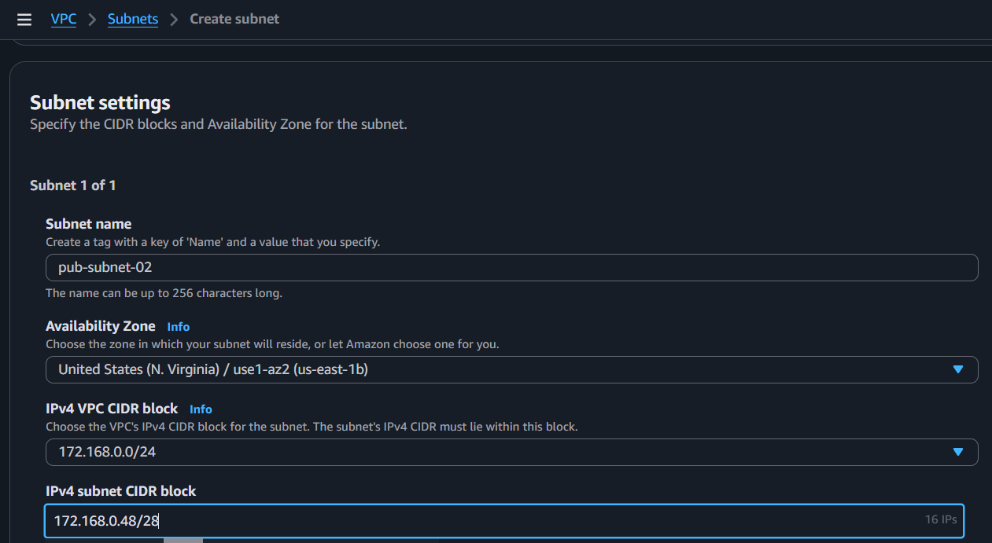
- 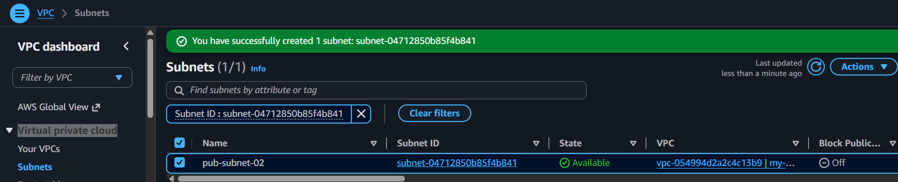

Now Attach Internet Gateway to VPC
We can create Internet Gateway or we can use default created by aws
- Go to internet gateway
Click on create

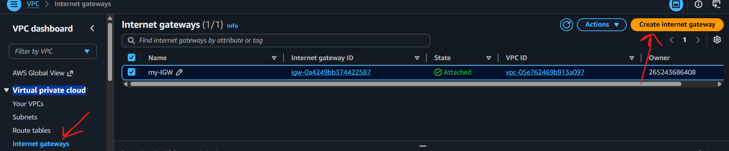
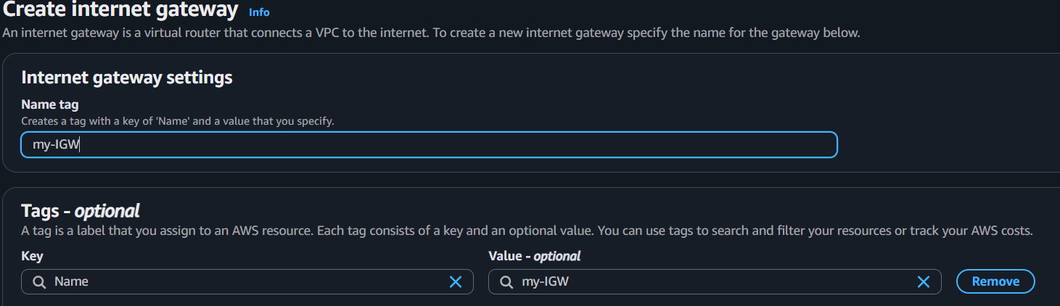

- After creation IGW
Click on Action --Attach to VPC
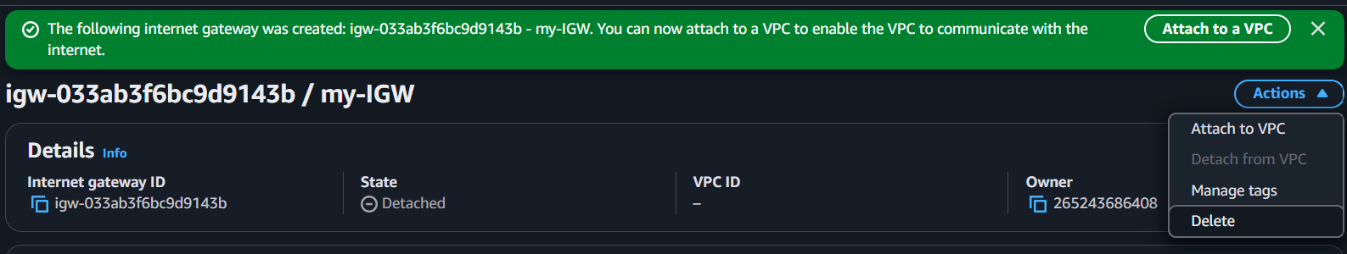
Select my-vpc
Click on Attach IG
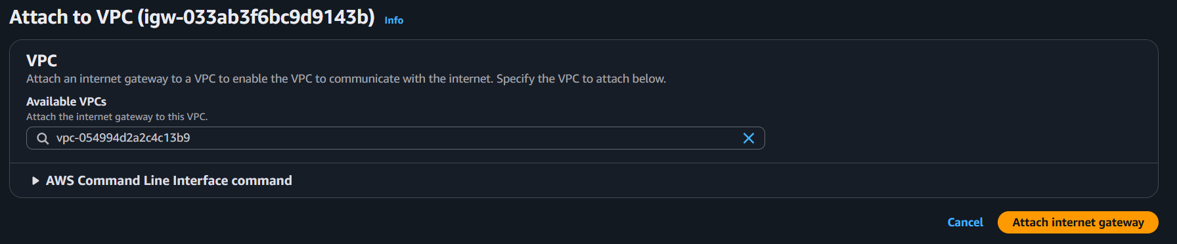

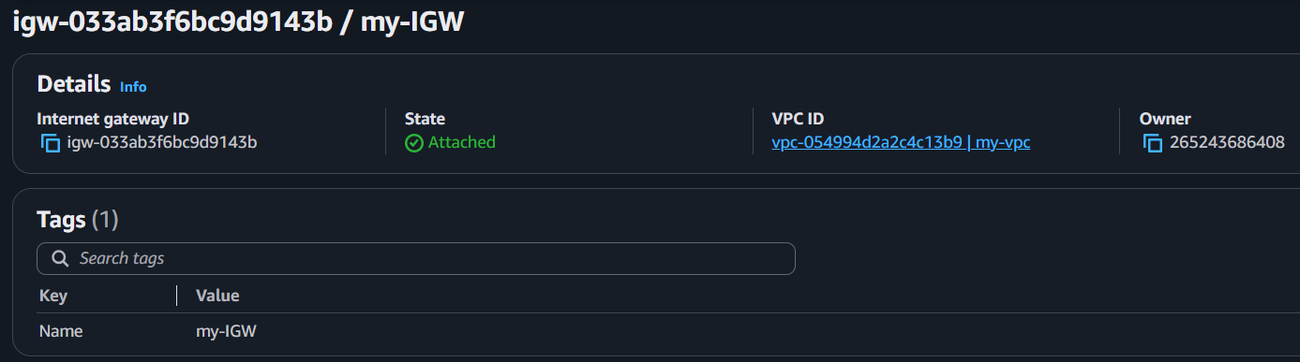
- Enable DNS Hostname in VPC.
It assigns a public DNS name to EC2 instances (if they have a public IP).

- Go to VPC.
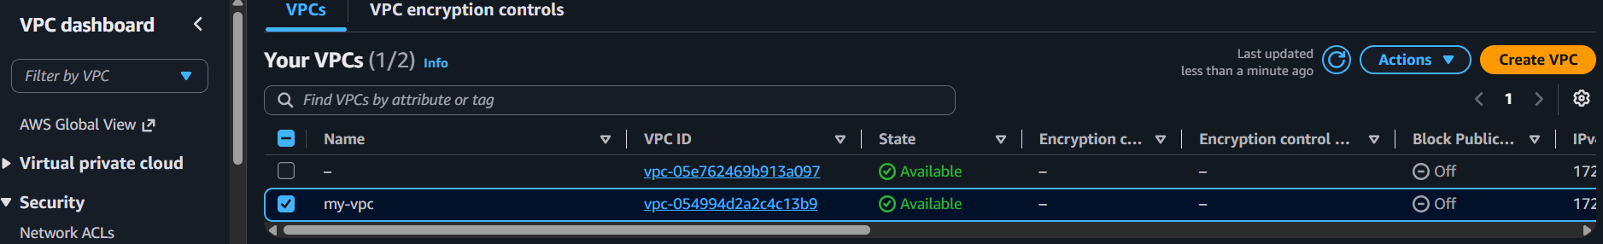
- Click Actions → Edit VPC settings.
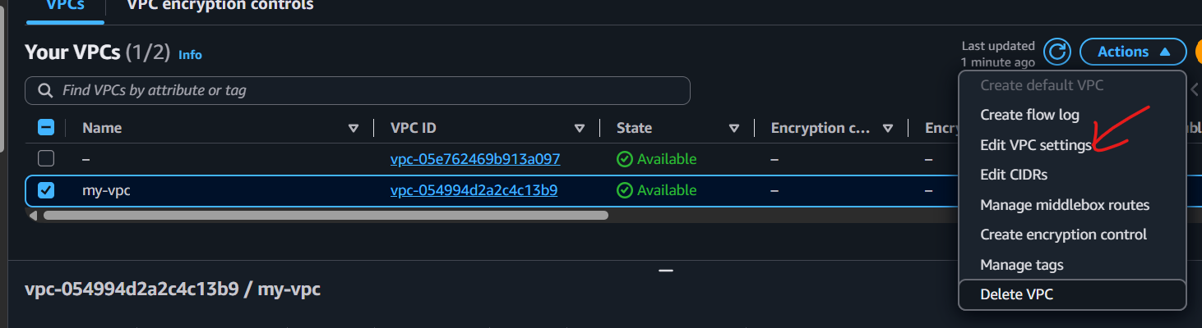
- Check Enable DNS hostnames.
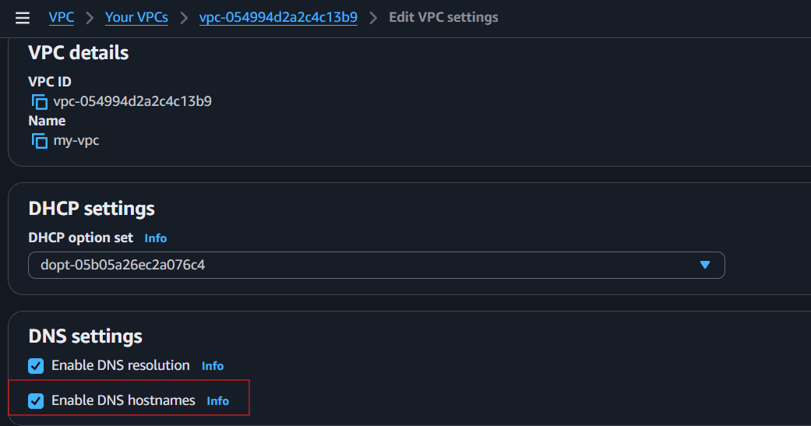
- Click Save.
✅ Done! DNS hostnames are now enabled for your VPC.

- Enable Auto Assign Public IP in 2 public subnets.
For Public Subnet 1
- Go to VPC → Subnets.
- Select pub-subnet-01.
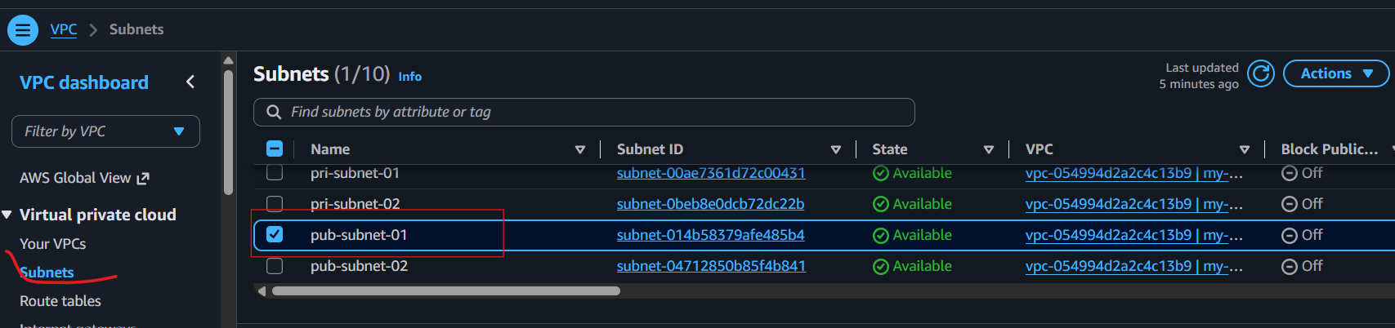
- Click Actions → Edit subnet settings.
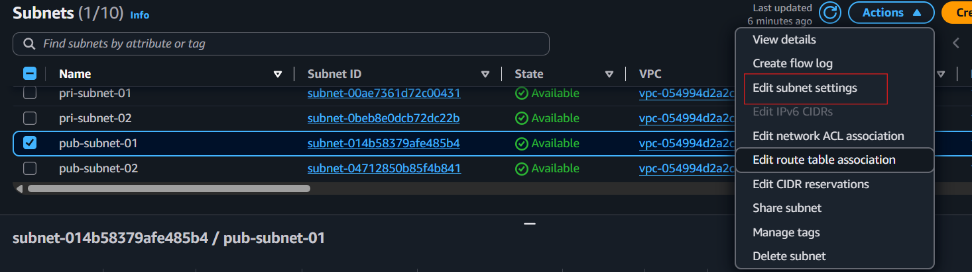
- Under Auto-assign IP settings, check:
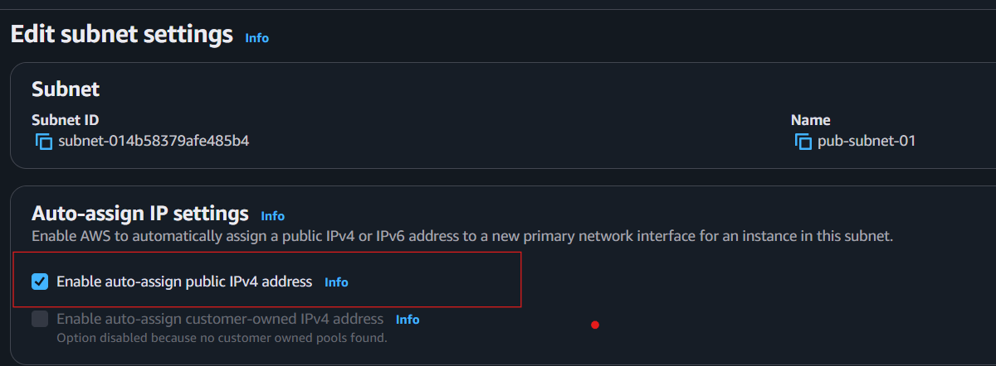
  - ✅ Enable auto-assign public IPv4 address

- Click Save.

For Public Subnet 2
- Select pub-subnet-02.
- Click Actions → Edit subnet settings.
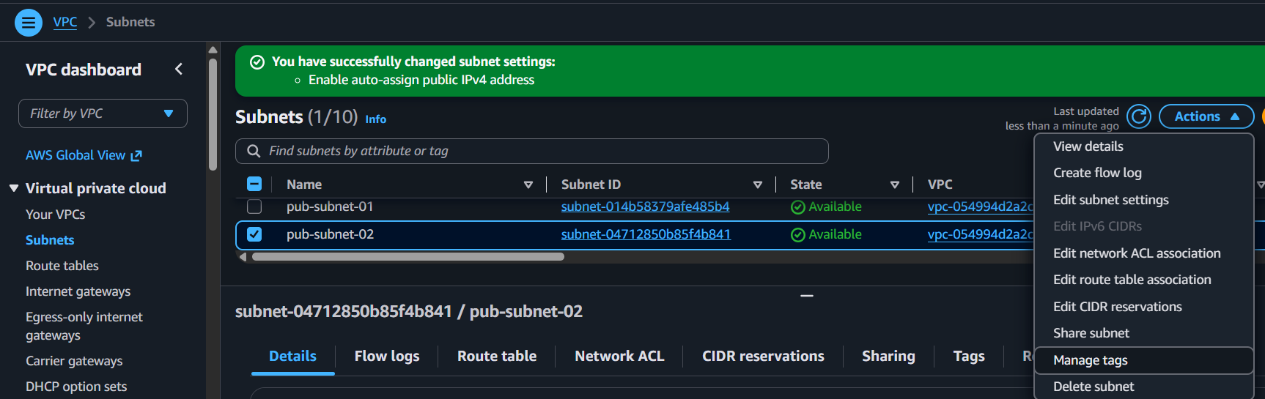
- Check:
  - ✅ Enable auto-assign public IPv4 address
- Click Save.
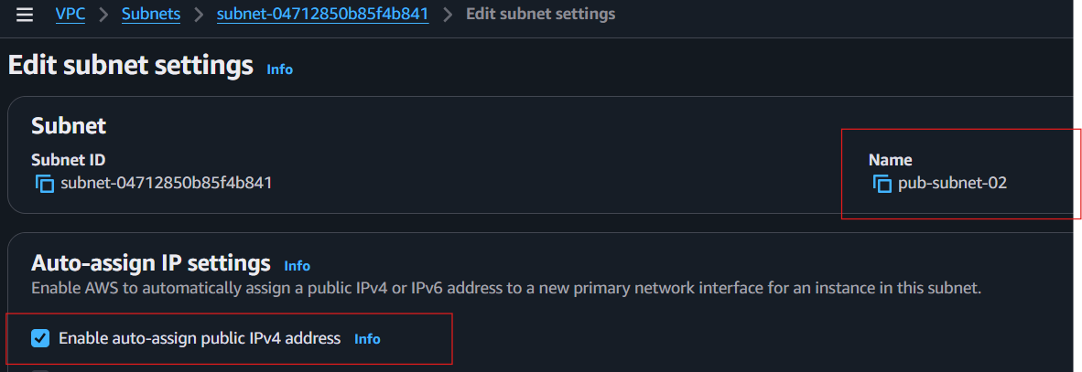
- Go to VPC → Subnets.
- Select each public subnet.
  - Auto-assign public IPv4 address = Yes
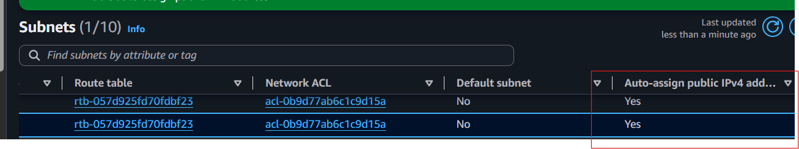
✅ Done! Any new EC2 instance launched in these public subnets will automatically receive a public IPv4 address.

- Add 2 private subnets in private route table.
- Go to VPC → Route Tables.
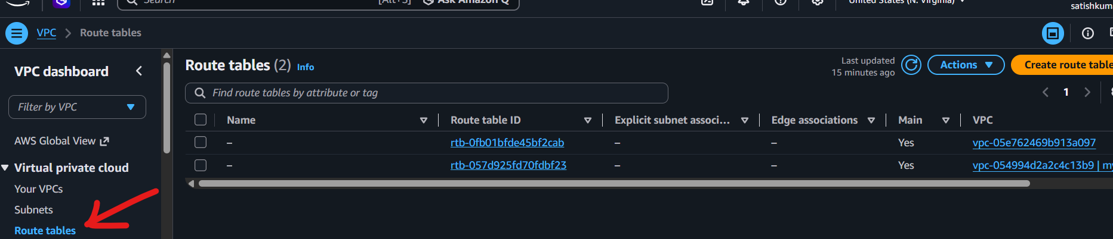
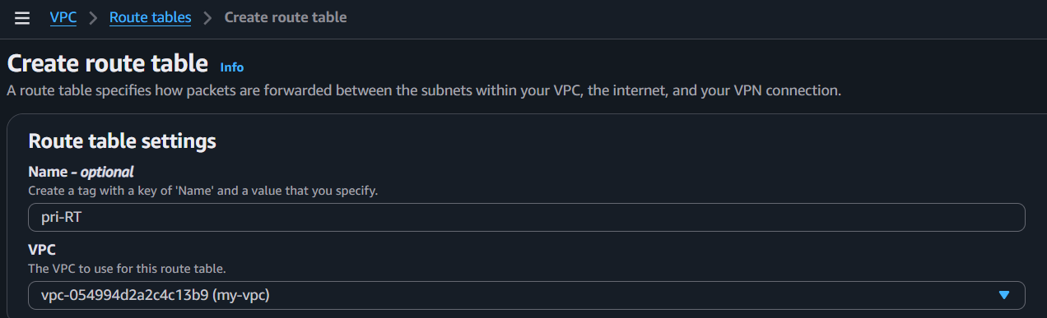
- Select your Private Route Table.
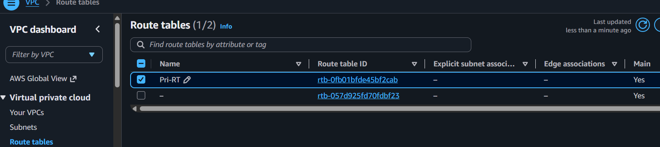
- Click the Subnet Associations tab.
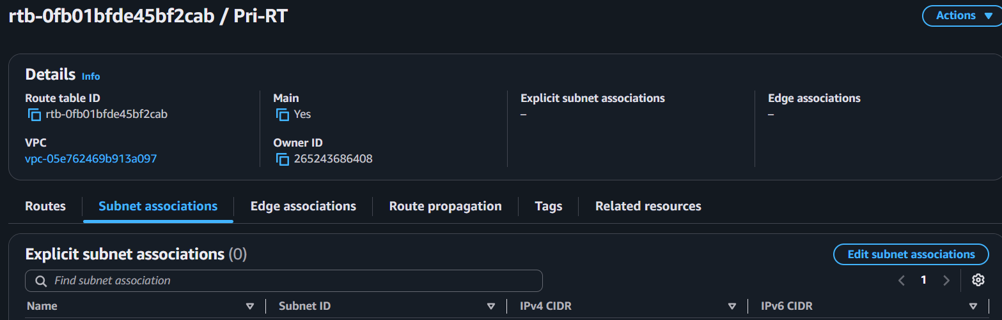
- Click Edit subnet associations.
- Check:
  - ✅ private-subnet-01
  - ✅ private-subnet-02
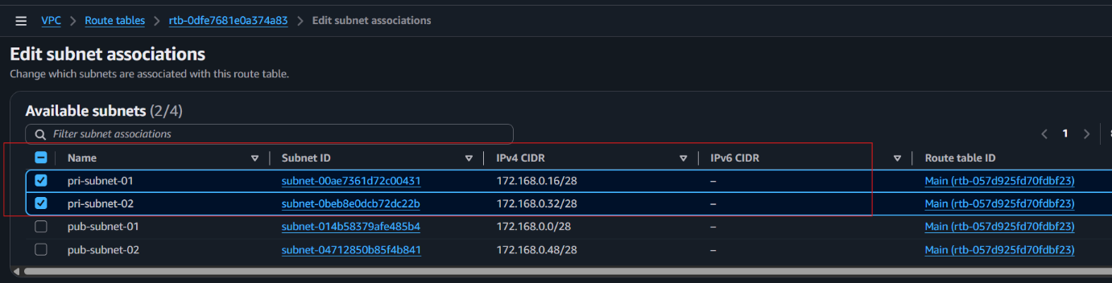
- Click Save associations.
Verify
- Open the Subnet Associations tab again.
- You should see:
  - ✅ private-subnet-01
  - ✅ private-subnet-02
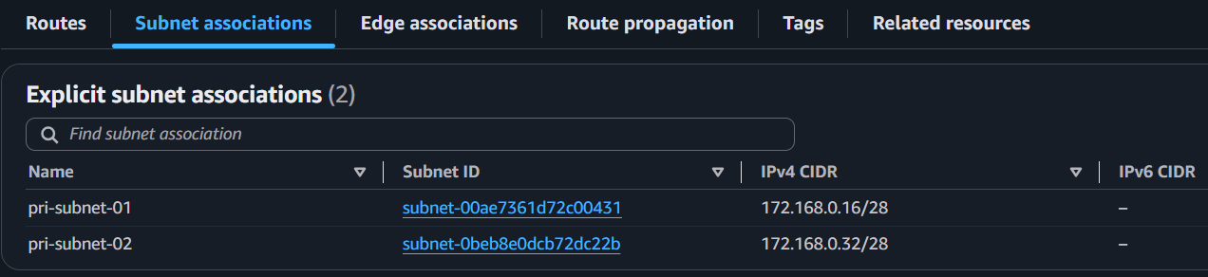
Done! Both private subnets are now associated with the private route table.

- Add 2 public subnets in public route table.
- Go to VPC → Route Tables.
- Create Route Table for Public
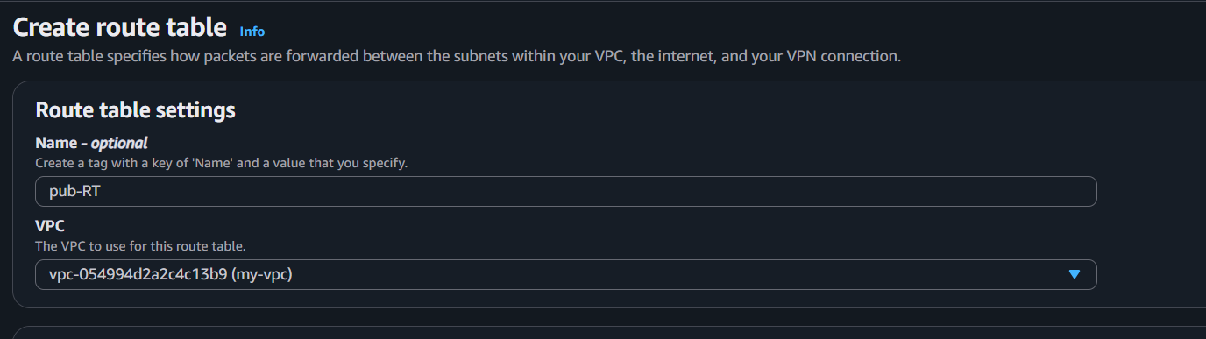
- Select your Public Route Table.
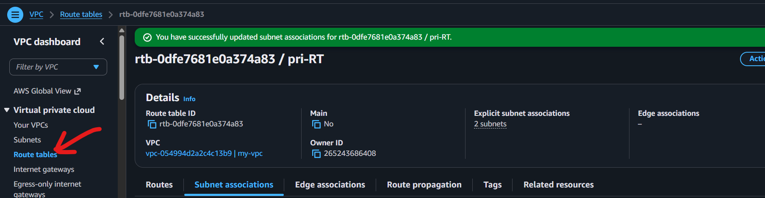
- Click the Subnet Associations tab.
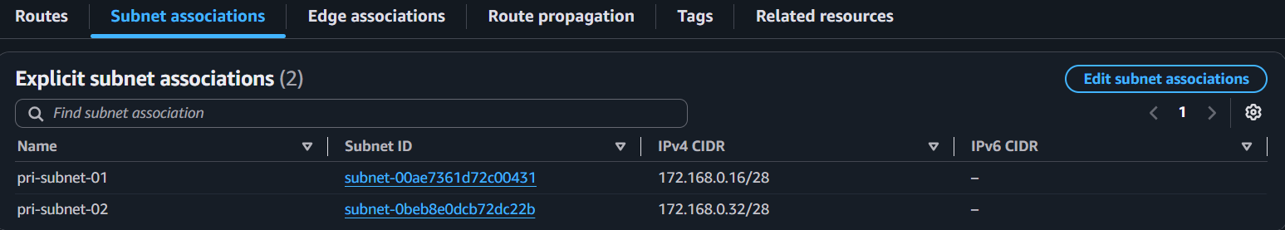
- Click Edit subnet associations.
- Select:
  - ✅ pub-subnet-01
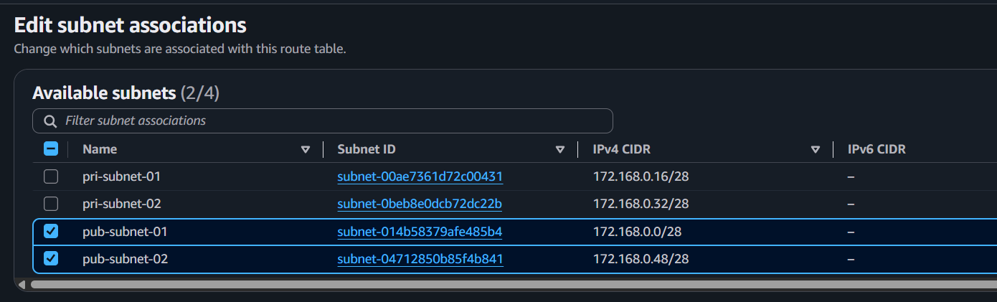
  - ✅ pub-subnet-02

- Click Save associations.
Verify
- Open the Subnet Associations tab.
- You should see:
  - ✅ pub-subnet-01
  - ✅ pub-subnet-02
Done! Both public subnets are now associated with the public route table.

- Public route table will have the routes to internet and local.

- Go to VPC → Route Tables.
- Select your Public Route Table.
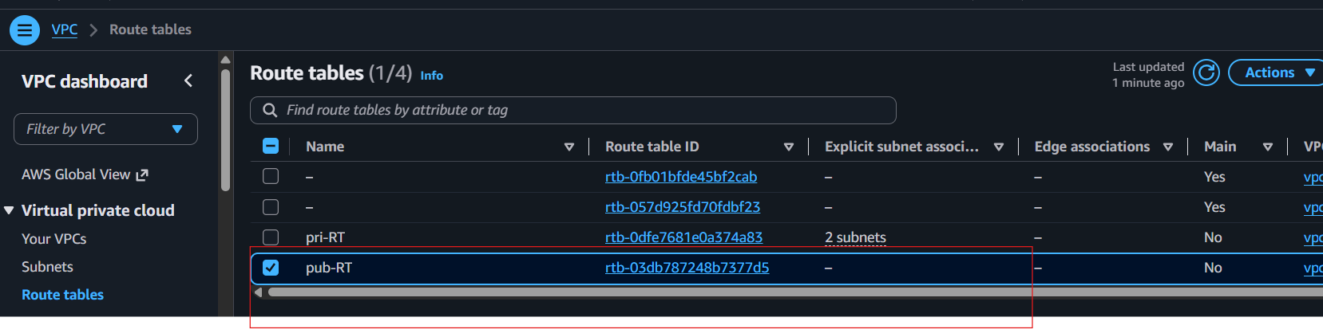
- Click the Routes tab.
- Click Edit routes.
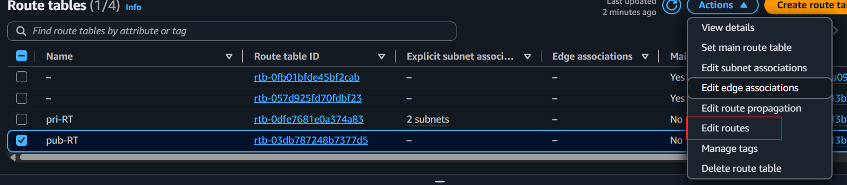
- Verify the following routes:
  - ✅ Destination: 172.168.0.0/24 → Target: Local
- click Add route and select your Internet Gateway as the target.
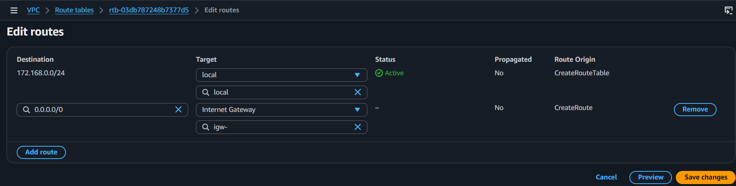
- Click Save changes.
✅ Done! Your public route table now has both the Local and Internet routes.

- Create EC2 in public subnet with t2.micro and install PHP.
Part 1: Launch EC2
- Go to EC2 → Instances → Launch instances.
- Name: PHP-Server
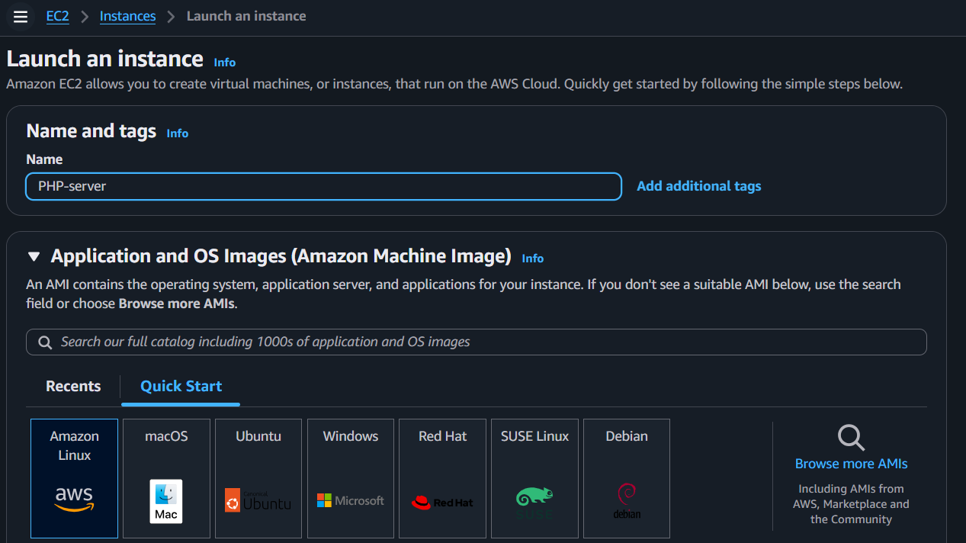
- AMI: Amazon Linux 2 (or Amazon Linux 2023)
- Instance type: t2.micro
- Select or create a Key Pair.
- Under Network settings:
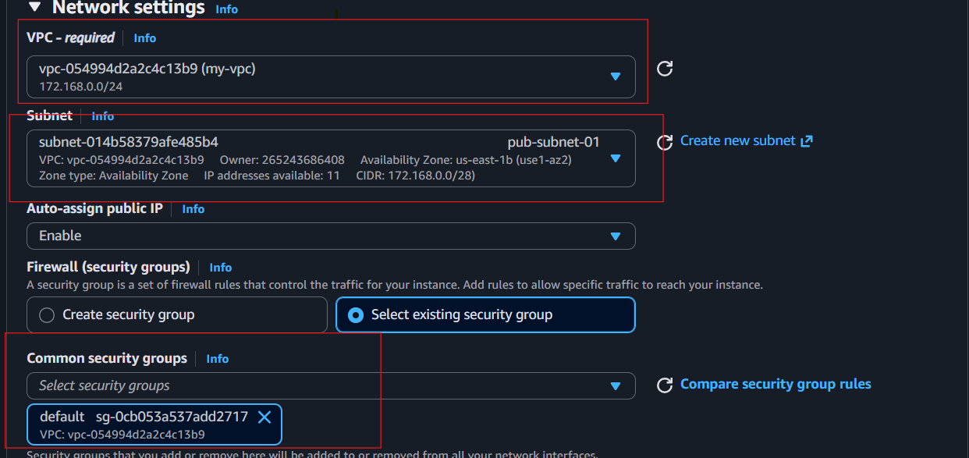
- Click Launch instance.
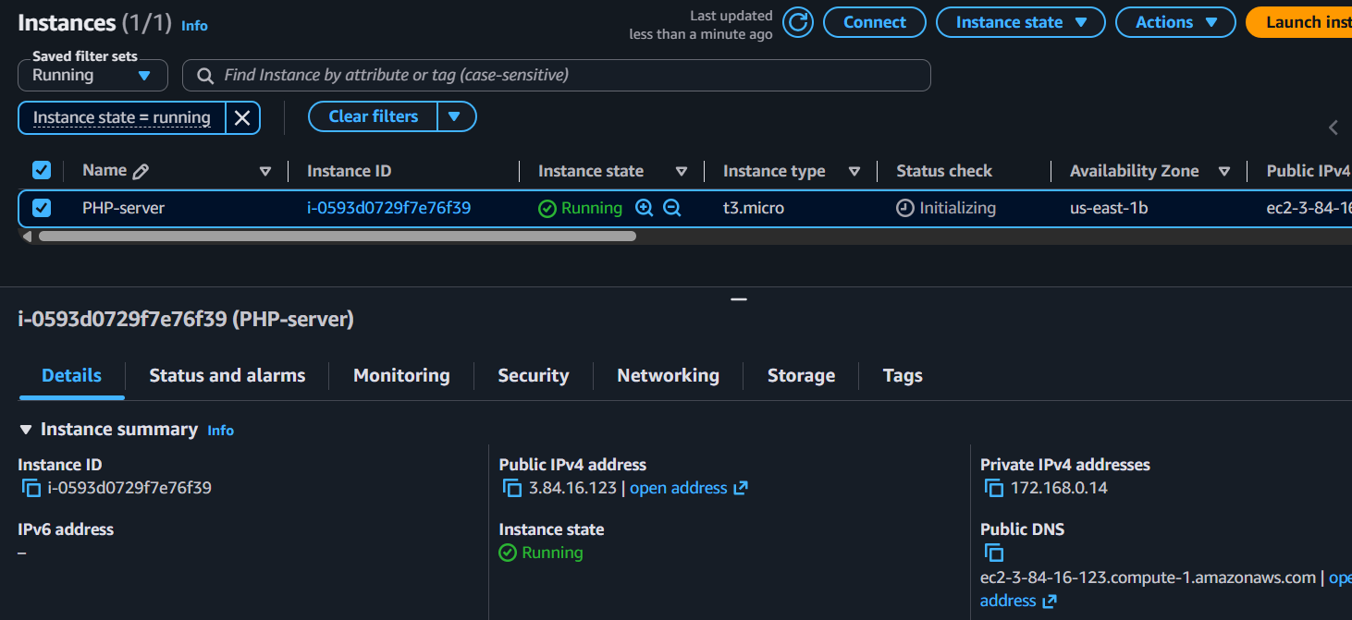

Part 2: Connect to EC2
- Select the instance.
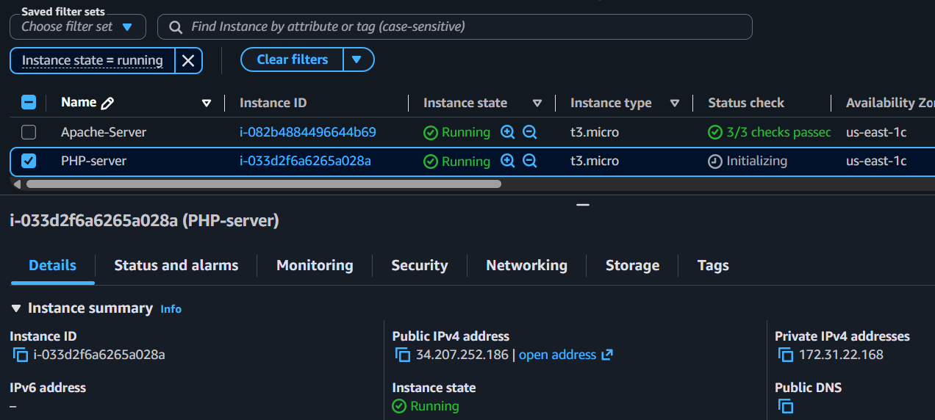
- Click Connect → EC2 Instance Connect (or SSH).
- Click Connect.
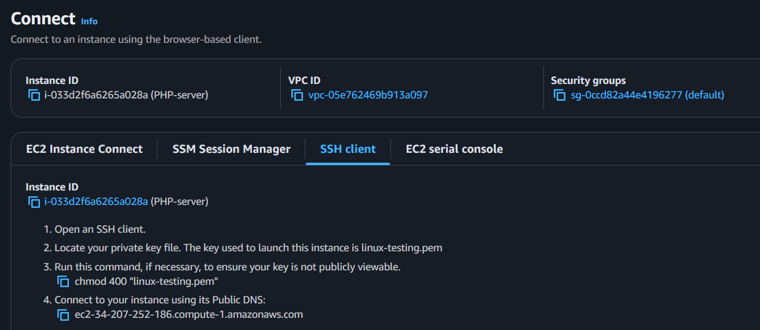

Part 3: Install PHP
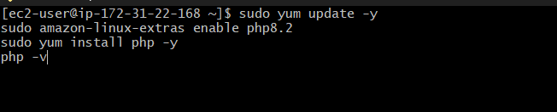
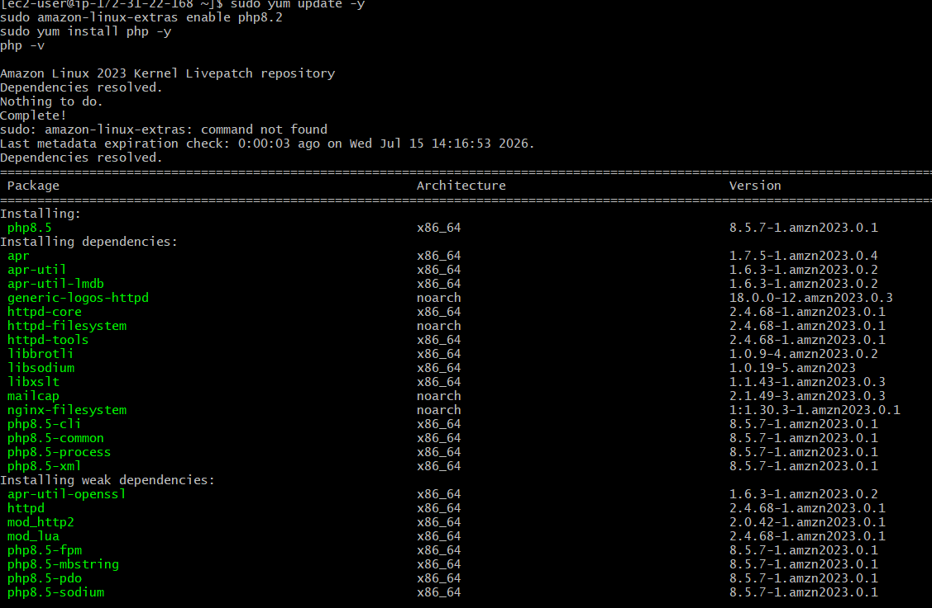
✅ Done! Your EC2 instance is running in the public subnet, and PHP is installed successfully.

- Configure NAT gateway in public subnet and connect to private instance.
Part 1: Create a NAT Gateway

- Go to VPC → NAT Gateways.
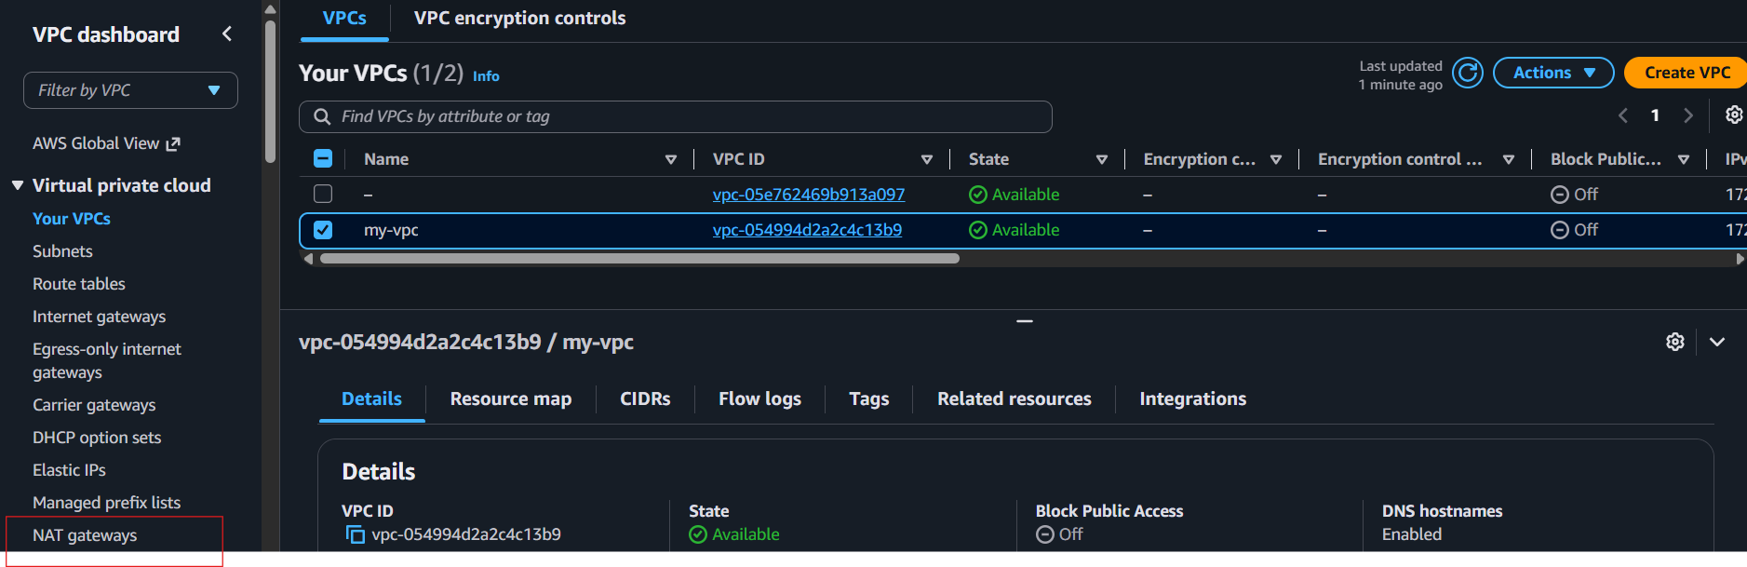
- Click Create NAT Gateway.
Name: NAT-Gateway
- Subnet: Select pub-subnet-01 (Public Subnet).
Click Allocate Elastic IP.
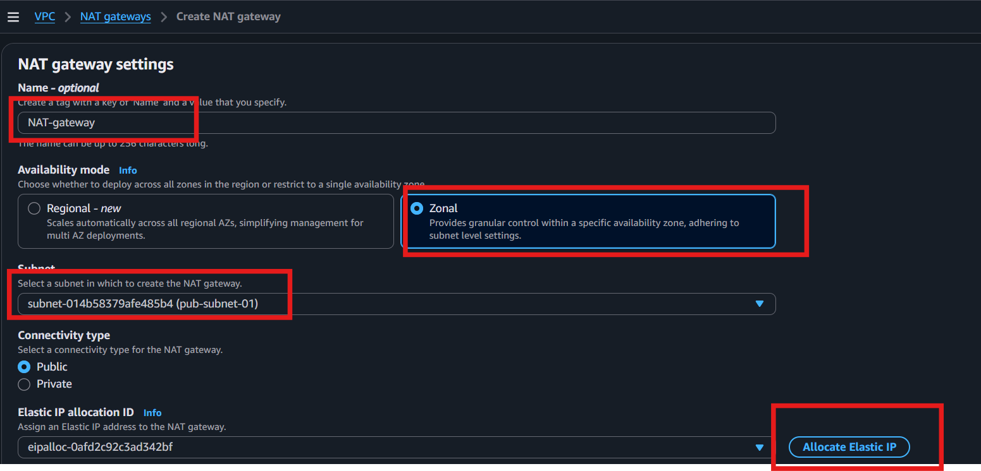
- Click Create NAT Gateway.
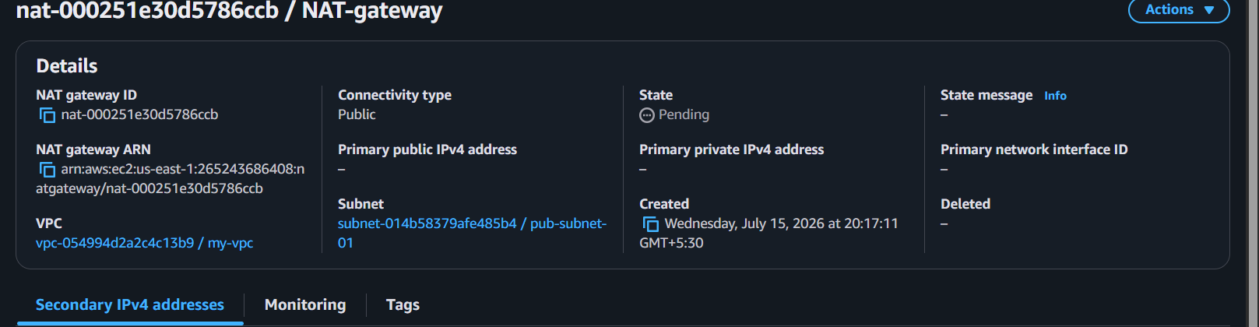

Part 2: Update the Private Route Table
- Go to VPC → Route Tables.
Select the Private Route Table.
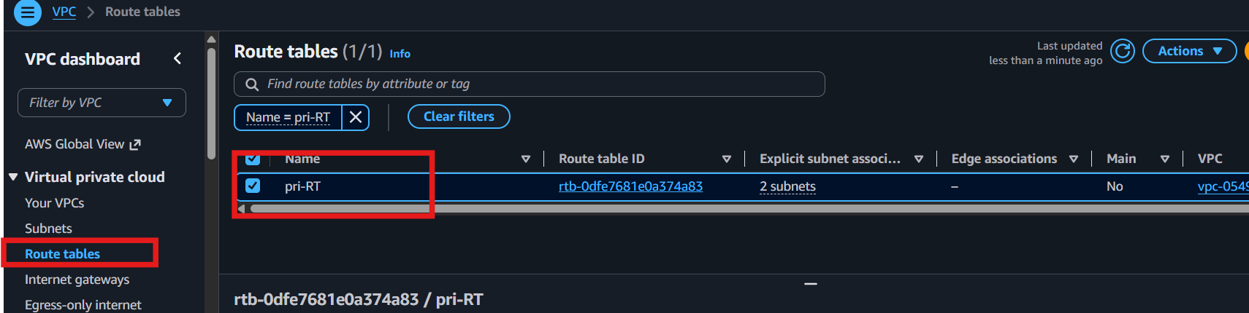
- Click Routes → Edit routes.
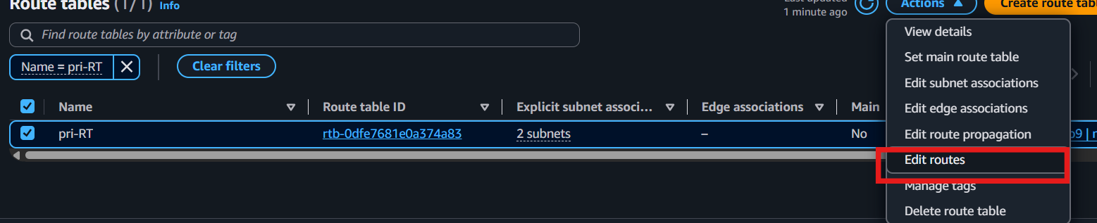
- Click Add route.
- Enter:
  - Destination: 0.0.0.0/0
  - Target: Select the NAT Gateway
Click Save changes.
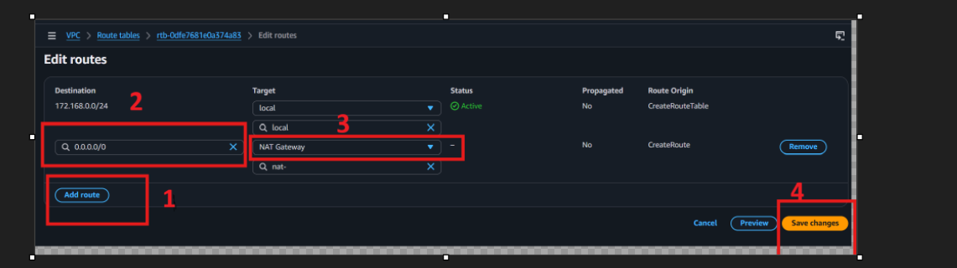

Part 3: Launch a Private EC2 Instance
- Go to EC2 → Launch instances.
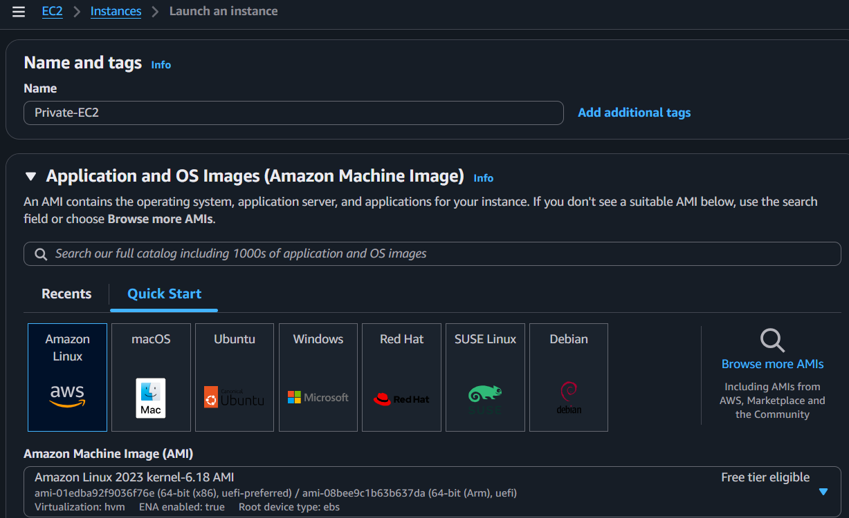
- Network settings
Select private-subnet-01 (or private-subnet-02).
Set Auto-assign Public IP = Disable.
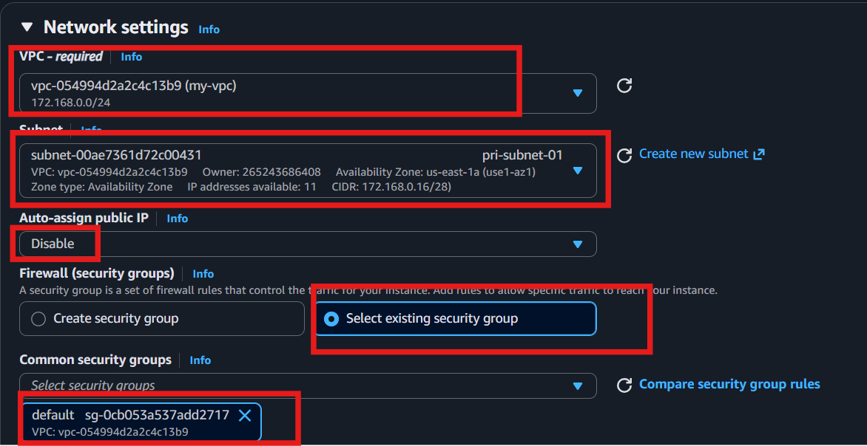
Launch the instance.

Part 4: Connect to the Private Instance
- Connect to your Public EC2 (Bastion Host) using SSH.
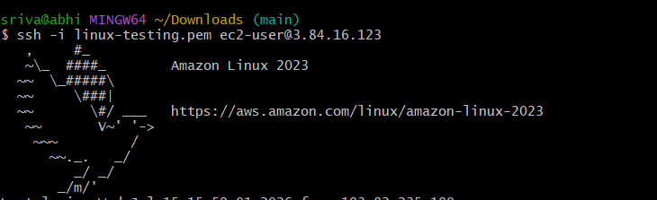
- From the Public EC2, SSH into the Private EC2 using its private IP:
ssh -i my-key.pem ec2-user@<Private-EC2-Private-IP>
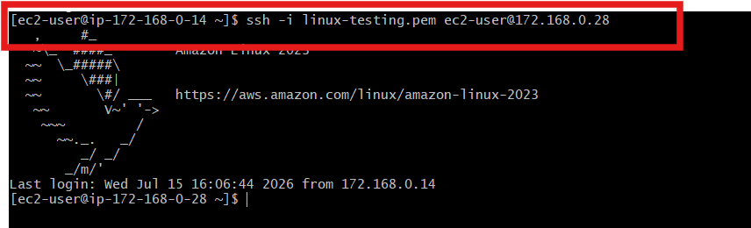

Part 5: Verify Internet Access from the Private EC2
Run: ping -c 4 google.com
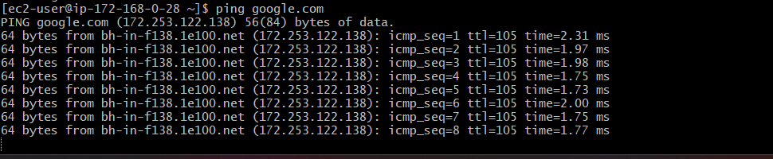
✅ Done! The private instance has outbound internet access through the NAT Gateway while remaining inaccessible directly from the internet.

- Install Apache Tomcat in private EC2 and deploy a sample app.

Step 1: Update the System
sudo dnf update -y
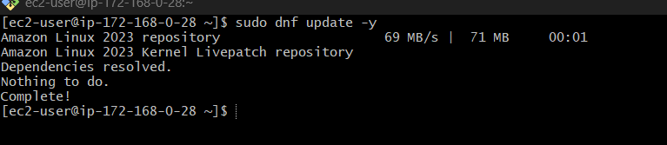

Step 2: Install Java
sudo dnf install java-17-amazon-corretto -y 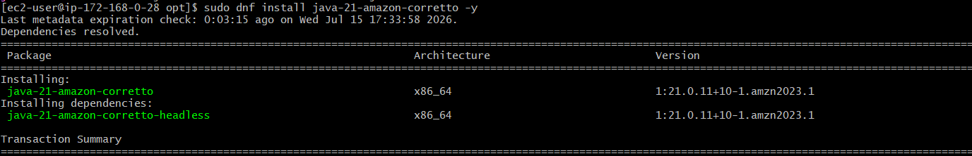
Check:
java -version

Step 4: Download Tomcat
cd /opt
sudo wget https://archive.apache.org/dist/tomcat/tomcat-10/v10.1.42/bin/apache-tomcat-10.1.42.tar.gz
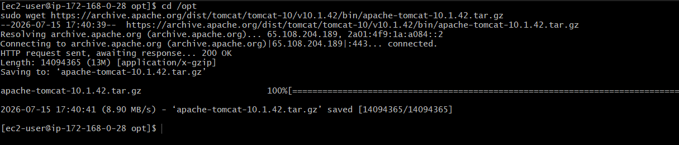

Step 5: Extract Tomcat
sudo tar -xzf apache-tomcat-10.1.42.tar.gz
sudo mv apache-tomcat-10.1.42 tomcat

Step 6: Start Tomcat
cd /opt/tomcat/bin
sudo chmod +x *.sh
sudo ./startup.sh
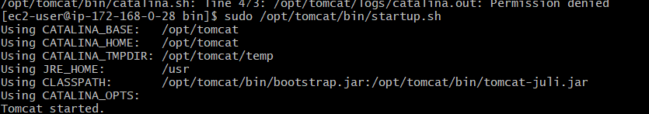

Step 7: Create a Sample App
cd /opt/tomcat/webapps
sudo mkdir sampleapp
sudo vi sampleapp/index.html
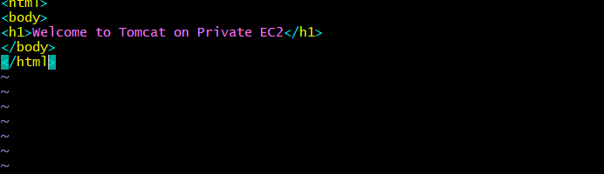
- Press Enter

Step 8: Verify the App
On the Private EC2:
curl http://localhost:8080/sampleapp/
Or from the Public EC2:
curl http://172.168.0.28:8080/sampleapp/
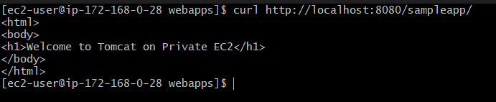
✅ If the HTML page is displayed, Tomcat and your sample application are running successfully.

- Configure VPC flow logs and store the logs in S3 and CloudWatch.
.
Step 1: Create an S3 Bucket
- Go to S3.
- Click Create bucket.
- Enter a unique bucket name.
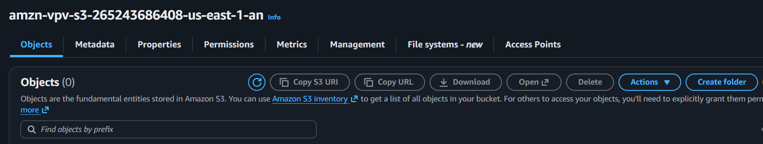
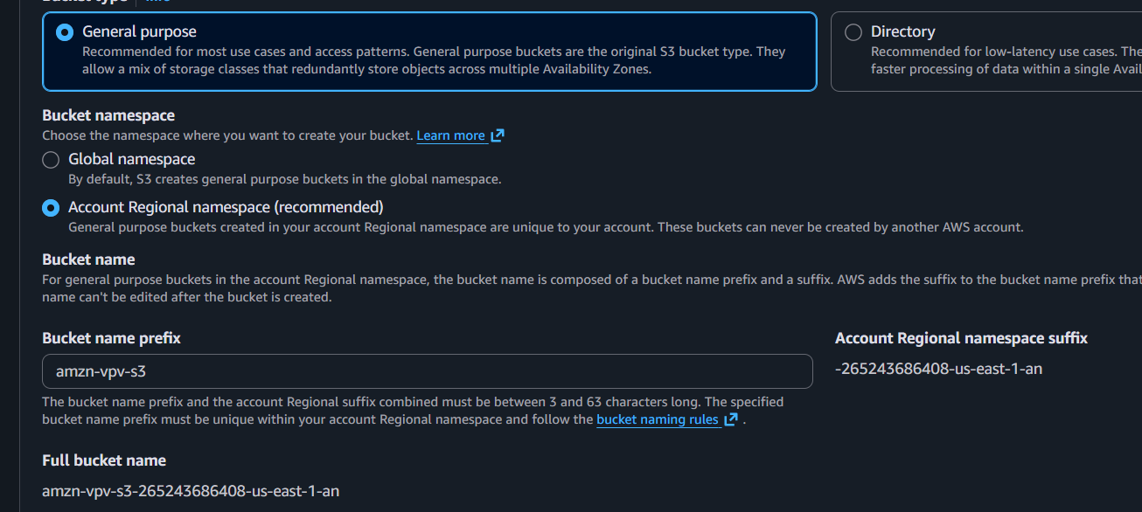
- Click Create bucket.

Step 2: Create a VPC Flow Log for S3
- Go to VPC → Your VPCs.
- Select your VPC.
- Click Actions → Create flow log.
- Configure:
  - Name: vpc-flow-log
  - Traffic type: All
  - Destination: Amazon S3
  - S3 Bucket ARN: arn:aws:s3:::your-bucket-name
- Click Create flow log.
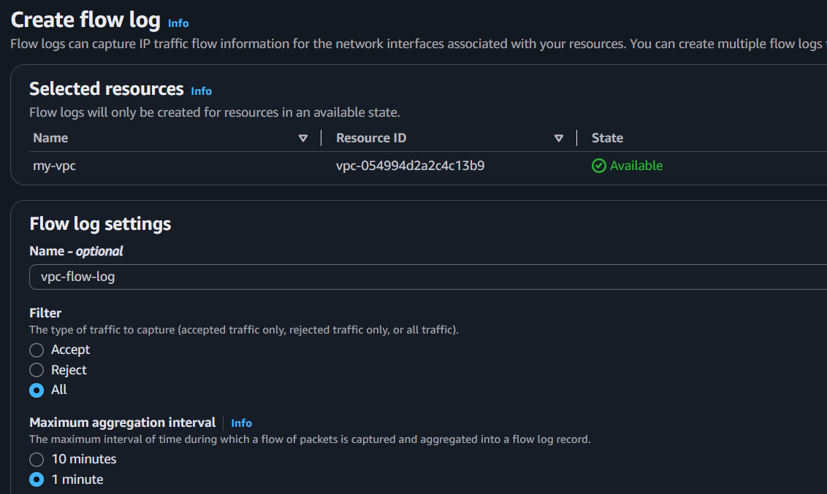
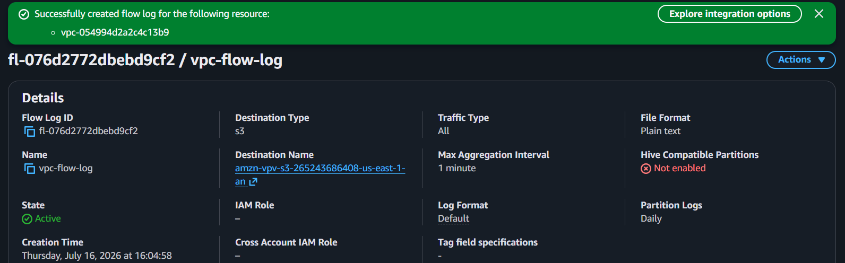
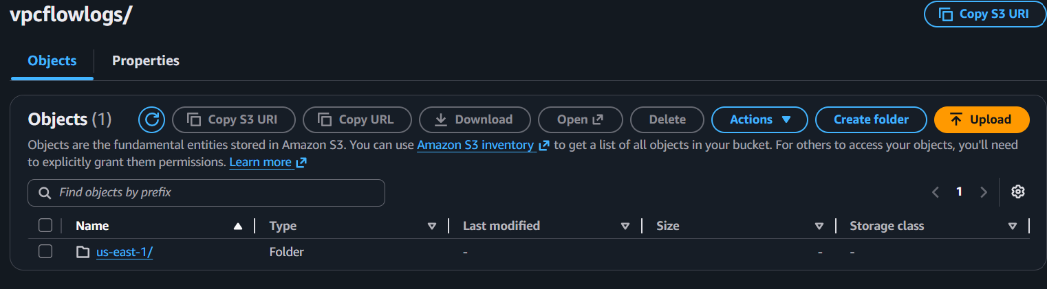

Step 3: Create a CloudWatch Log Group
- Go to CloudWatch.
- Click Log Management → Log groups.
- Click Create log group.
- Name : VPCFlowLogs
- Click Create.
- Copy the ARN
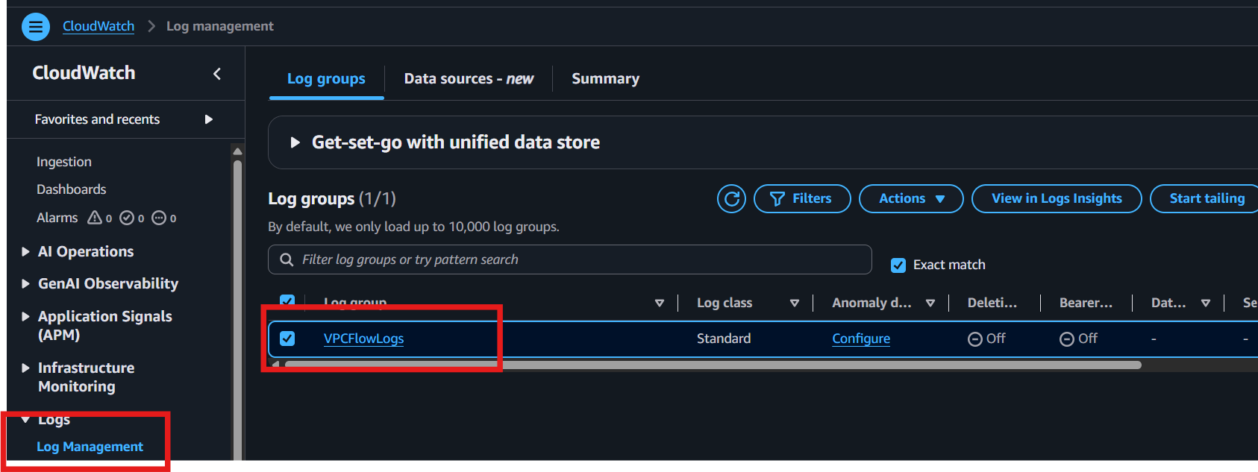
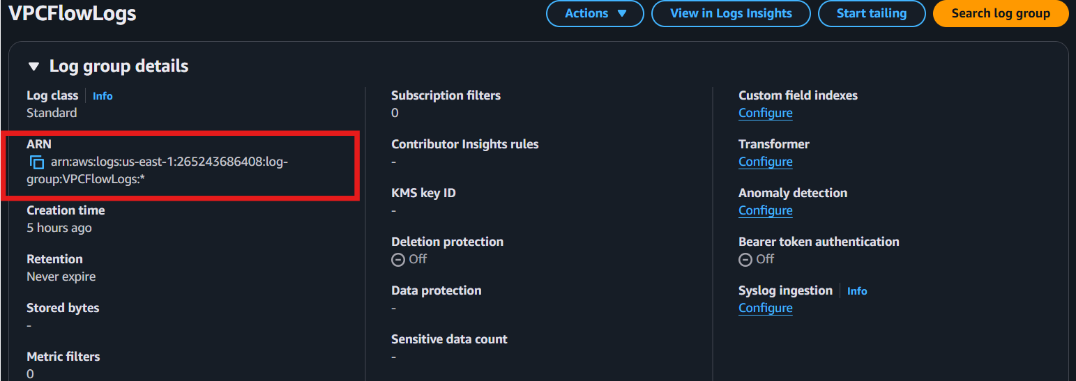
- Go back to vpc flow log
- Crate IAM role
- AWS Console → IAM
Step 2: Create Policy (Optional)
- Click Policies → Create policy.
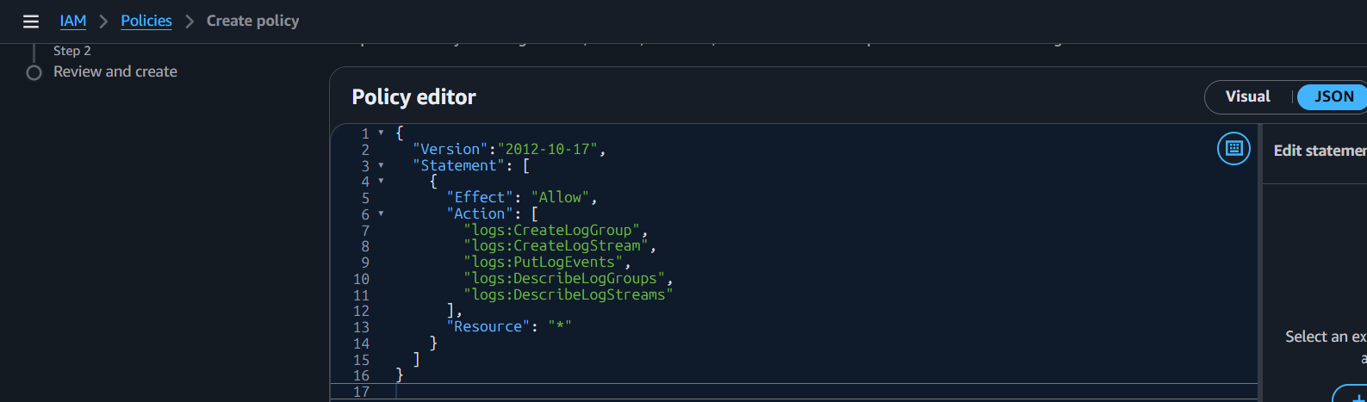
- Choose CloudWatch Logs permissions
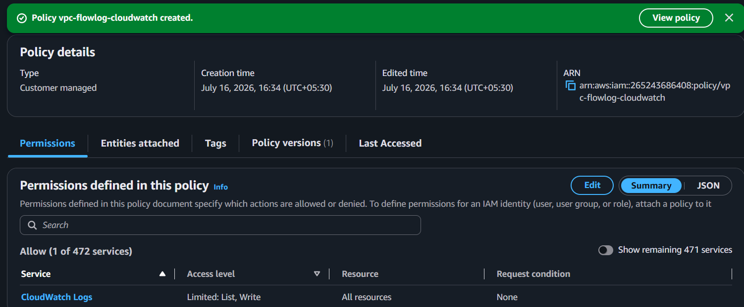
- Step 3: Create Role
- Go to Roles → Create role.
- Select Custom trust policy
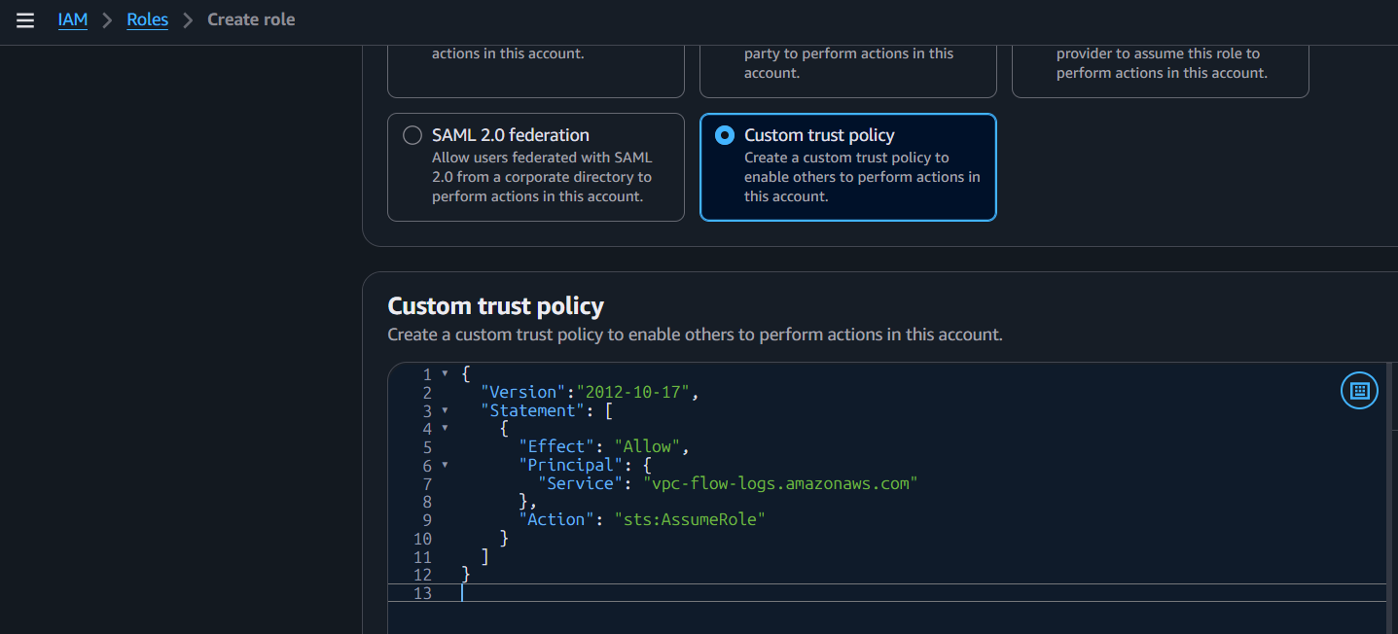
- Choose VPC Flow Logs
- Click Next.
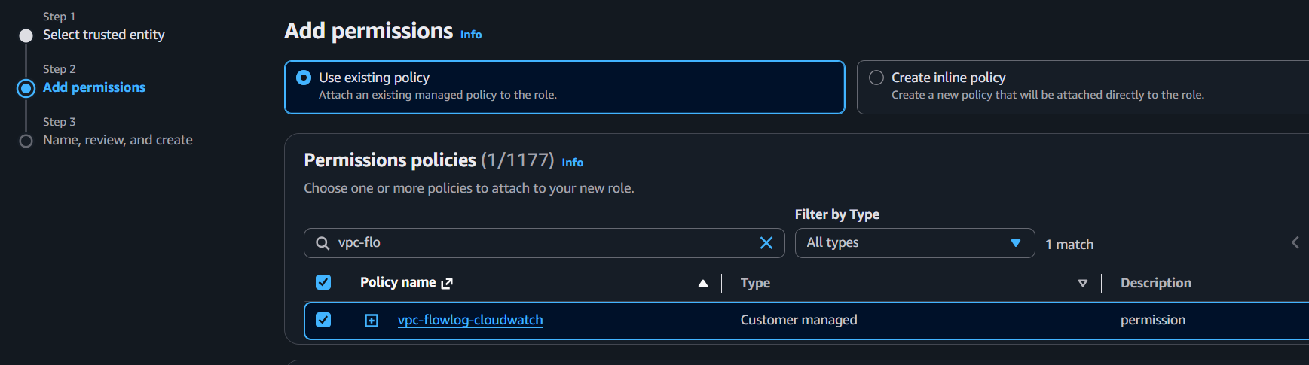
Step 4: Attach Policy
- Search for: vpc-flowlog-cloudwatch
- Click Next.
Step 5: Create Role
- Role name: vpc-flowlog-role
- Click Create role.
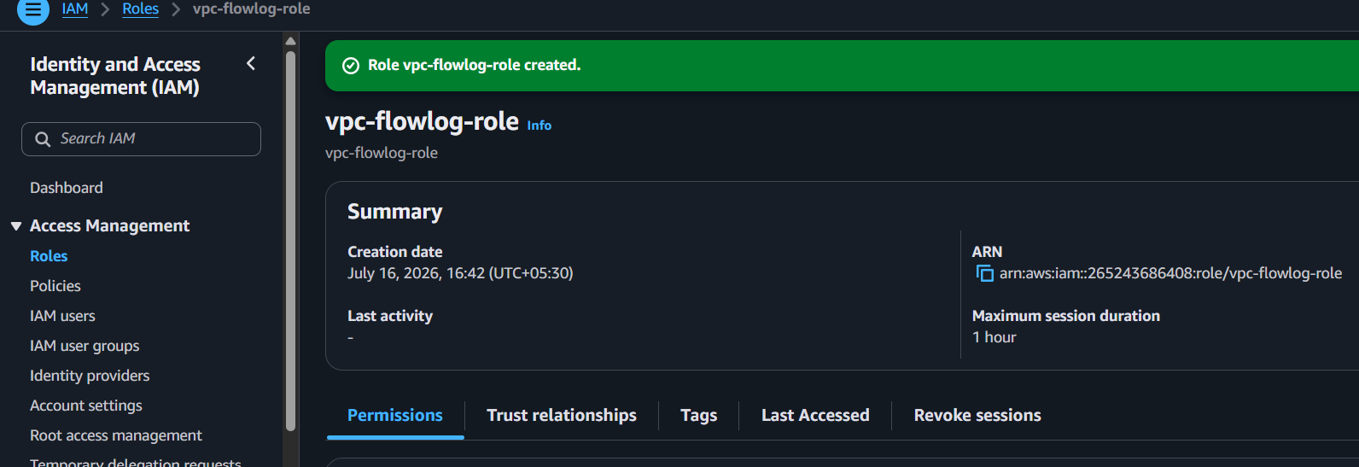

Go back to vpc flow log
- Destination log group
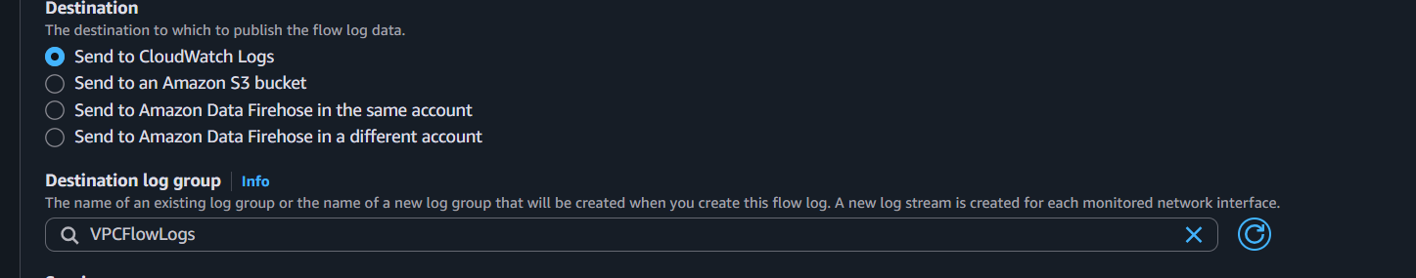
Select : VPCFlowLogs
Click on create flow log
